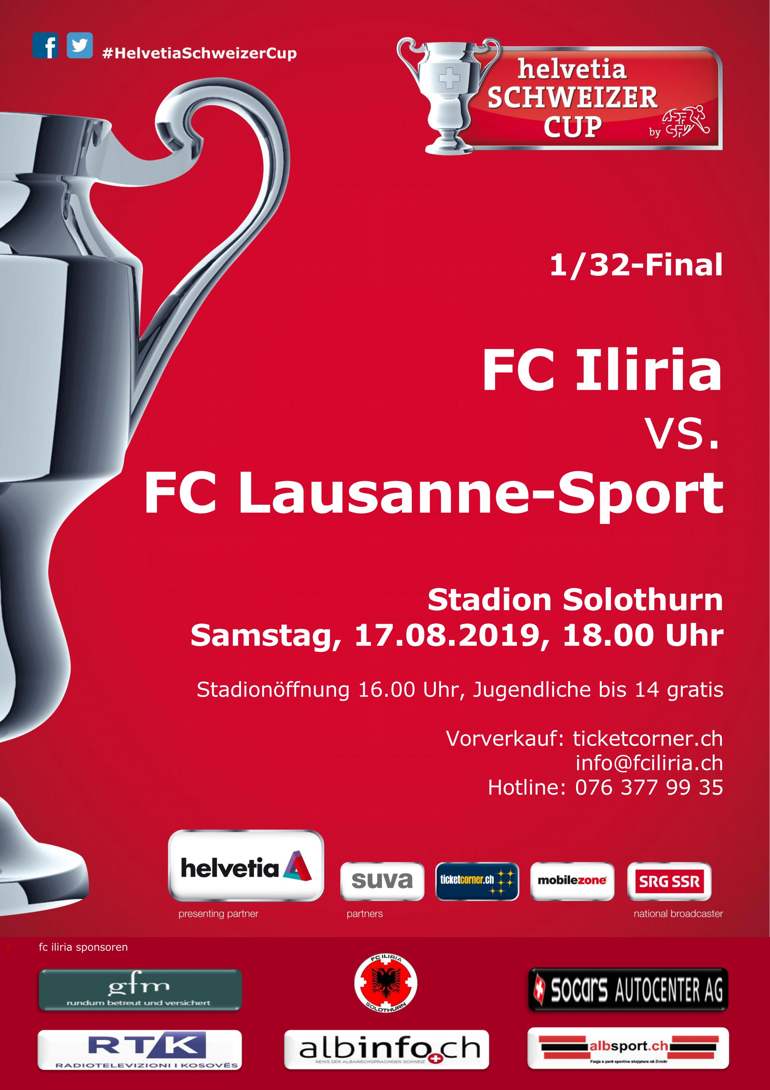

Liebe Matchbesucher/innen
Der FC Iliria Solothurn begrüsst Sie recht herzlich zum heutigen Helvetia Schweizer Cup Spiel 1/32 Final, im Stadion FC Solothurn.
Unser heutiger Gegner aus der Challenge League ist der Club FC Lausanne-Sport.

Für unsere Mannschaft ist dies eine weitere Erfahrung im Schweizer Cup. Nach der sehr kurzen Sommerpause haben die Spieler das Training wieder aufgenommen. Leider konnte die Vorbereitung wegen vielen Ferienabsenzen nicht optimal ausgenutzt werden.
Jetzt gilt es um so mehr mit viel Leidenschaft, Einsatz und vor allem mit Charakter zu spielen mit welchem sich der FC Iliria in der abgelaufenen Saison gezeigt hat.

Ganz herzlich bedanken möchten wir uns an dieser Stelle bei unseren Sponsoren, die unseren Verein grosszügig unterstützen. Ein spezieller Dank geht auch an unsere Fans, die uns mit viel Herz während der ganzen Saison begleitet haben.
Nun wünschen wir im Namen des FC ILIRIA allen Zuschauern und unseren Gästen aus Lausanne einen angehnehmen Aufenthalt im Stadion FC Solothurn. Wir wünschen beiden Teams viel Glück!

HOPP FCI

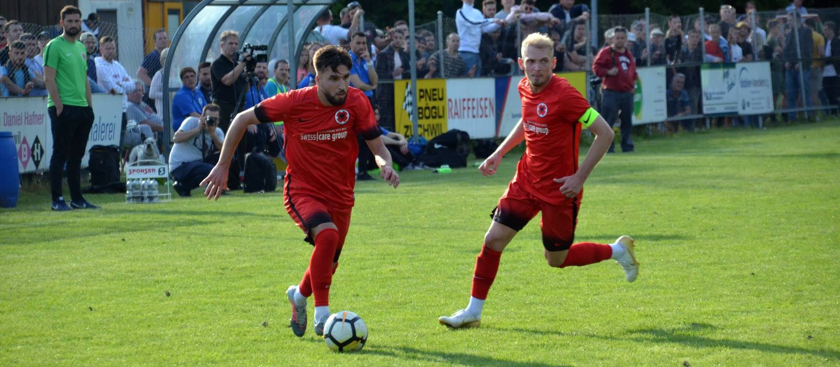
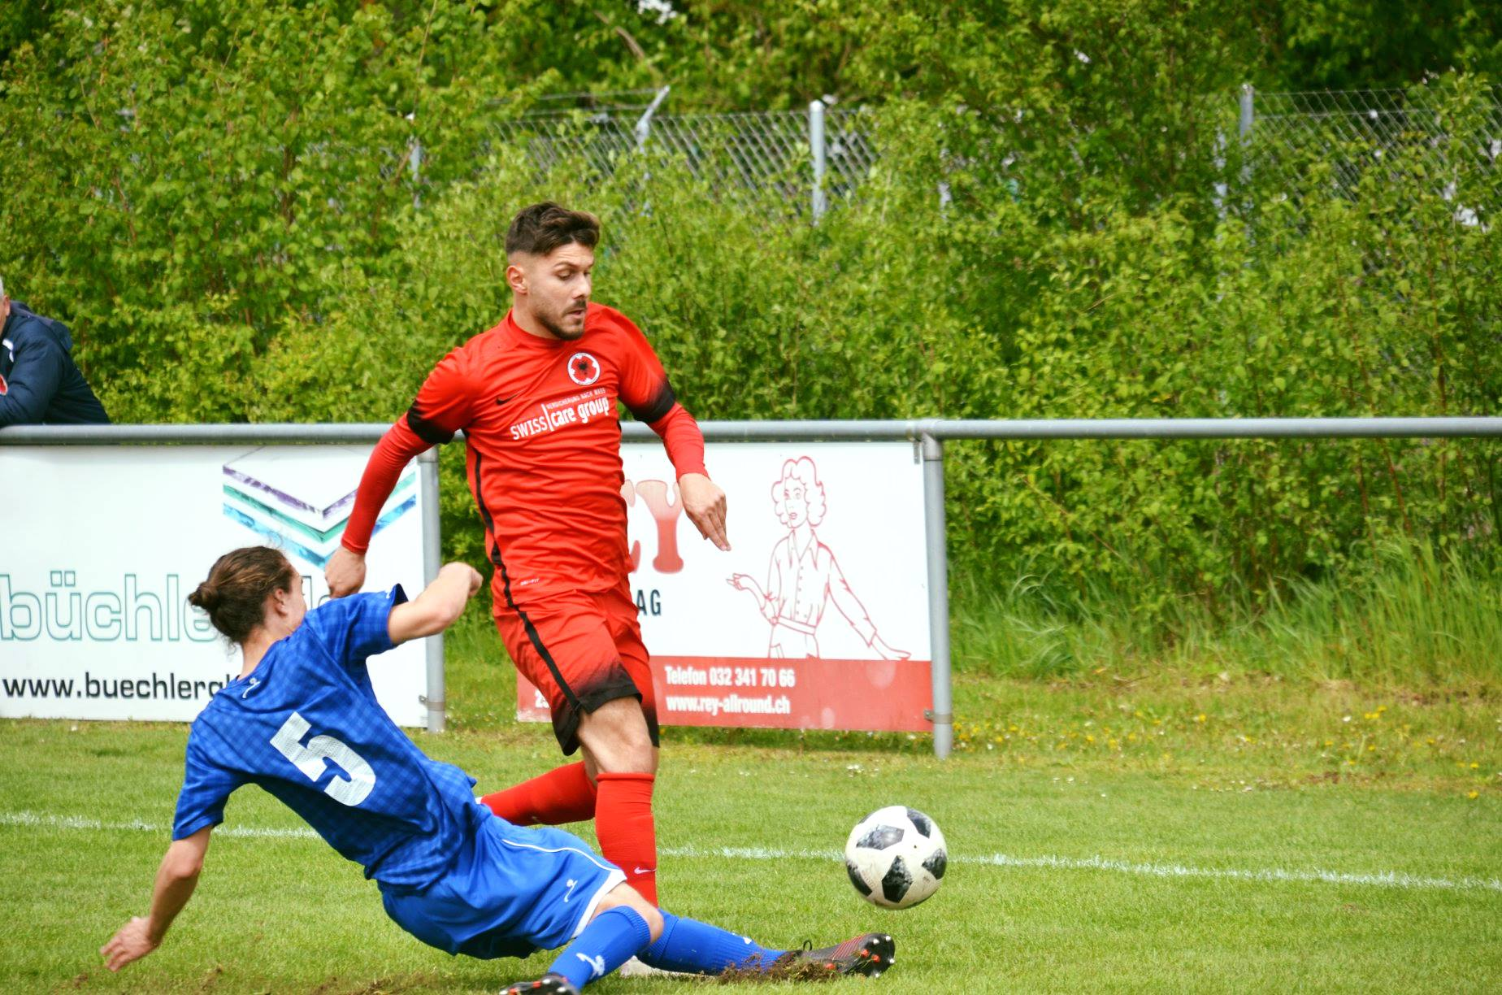
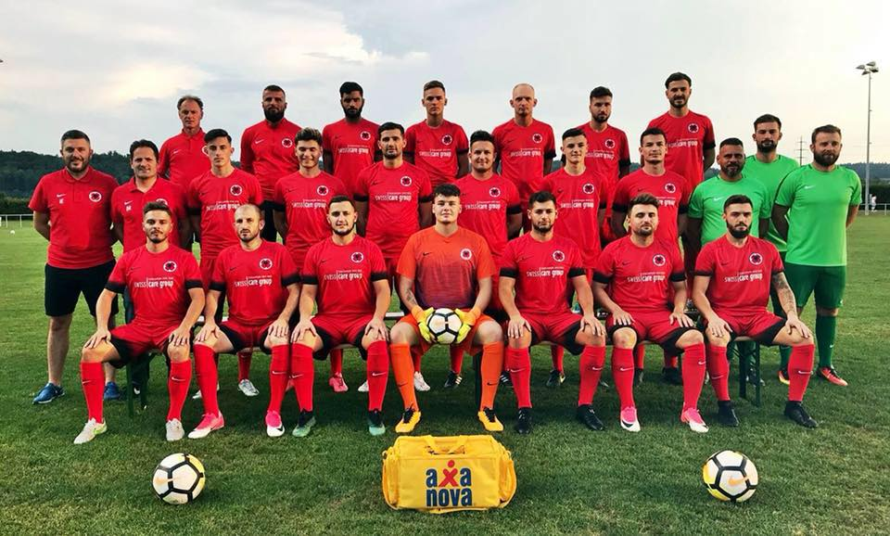
Nr. | Name | Pos. | Jahrg. |  | Nr. | Name | Pos. | Jahrg.
1 | Trittibach Nicola | T | 94 |  | 22 | Elezi Nazim | M | 94
21 | Shkoreti Laurent | T | 00 |  | 23 | Dakaj Bleron | M | 97
4 | Spaiu Syart | V | 00 |  | 26 | Perkolaj Denis | M | 00
5 | Halimi Avdi | V | 97 |  | 9 | Prenaj Samuel | S | 93
13 | Latifi Leutrim | V | 93 |  | 19 | Aliu Duan | S | 02
16 | Raimi Burim | V | 95 |  | 25 | Idrizi Bleon | S | 00
18 | Sulejmani Dashnim | V | 93 |  | 27 | Andrijasevic Oliver | S | 94
20 | Zizak Ivo | V | 92
24 | Dedaj Dugagjin | V | 89
6 | Llugaliu Dardan | M | 94
7 | Jahiu Alban © | M | 91
8 | Sadriji Mergim | M | 92
10 | Mustafi Egzon | M | 95
11 | Sasso Mattia | M | 95
12 | Mustafi Memnum | M | 95 |  | Staff
14 | Gedici Hasan | M | 92 |  | Dedaj Vilson (Trainer) Sasso Leo (Trainer)
15 | Dhillon Jasminder | M | 97 |  | Plemenic Tarik (THT) Elezi Real (Masseur)
17 | Caroli Riccardo | M | 98

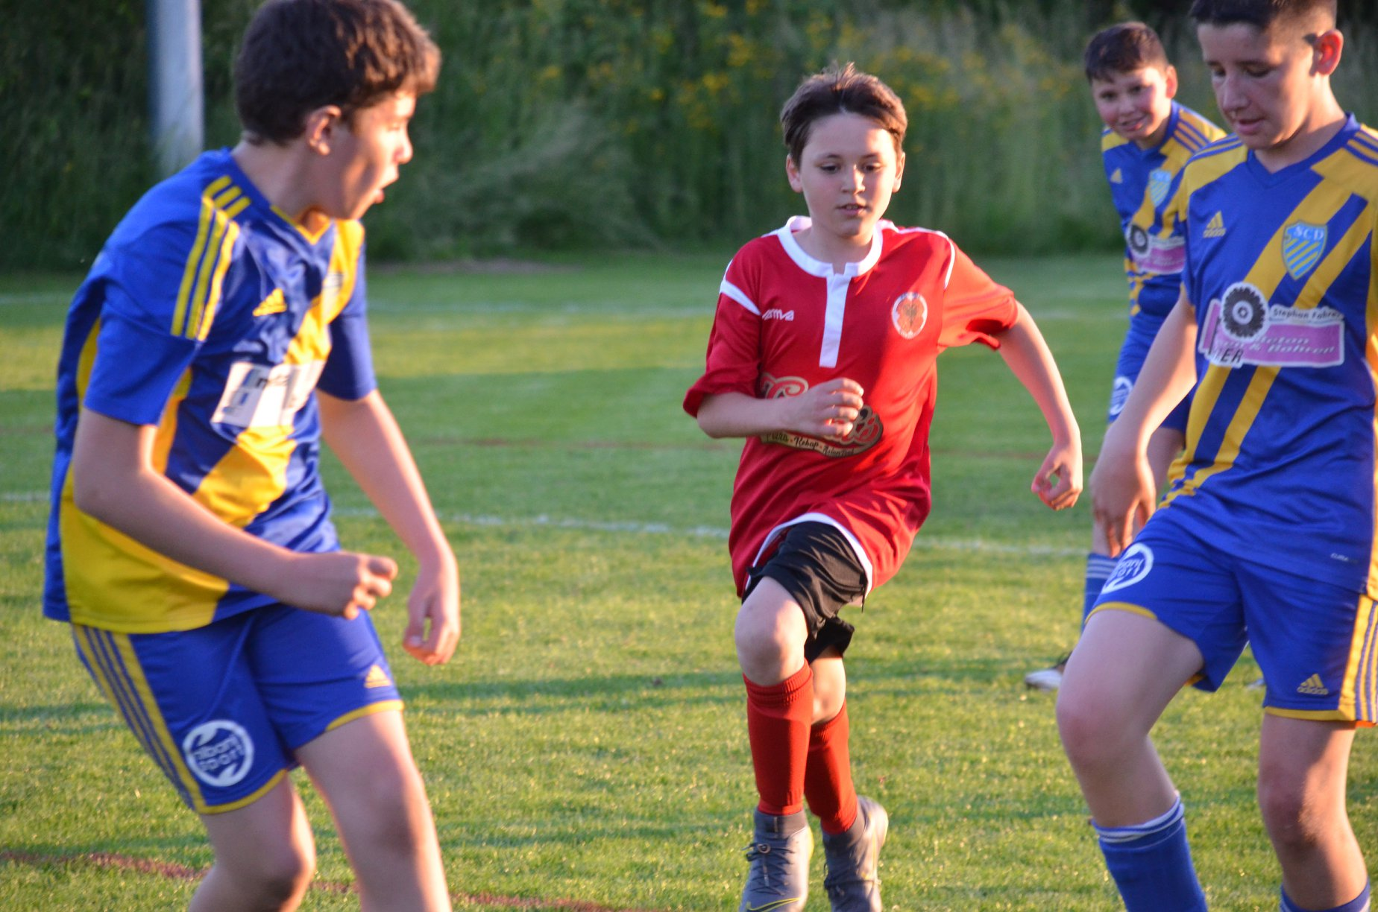
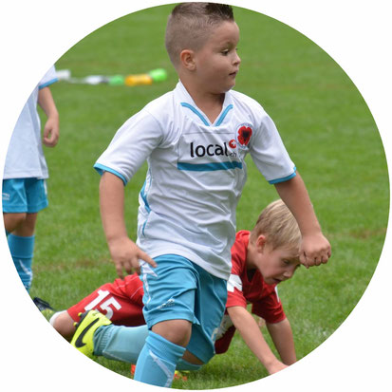
ABR Autospritzwerk Nuraj, Aarburg
Agathon AG, Bellach
Allianz Hauptagentur, Oftringen
Andres AG Präzisionsdrehteile, Lohn
Aquide AG U/beratung, Volketswil
Alosint Pulverbeschichtung GmbH, Langenthal
Argjenderi Robert Dedaj, Gjakova
ASIX AG Wolfwil, Dullaj Xhevxhet
Auto Marino & Genier GmbH, Lengnau
Auto Mosconi, Lengnau
Auto Rexhepi, Derendingen
AXA Vorsorge & Vermögen, Zürich
BANK CLER AG, Solothurn
Beciri GmbH Lengnau BE
Berchtold Kältetechnik, Niederbipp
Bohrteam Ketta GmbH, Urdorf
Büchel Bestattungen, Derendingen
Carrosserie Jost, Herzogenbuchsee
Coiffeur LEO.S, Zuchwil
Deli Bau GmbH, Gerlafingen
Dilara Bar, Zuchwil
DS Smith Packing AG, Oftringen
Edo-Risi GmbH, Zuchwil
Esprit-Garage AG, Zuchwil
Fahrschule Straubhaar, Solothurn
Falcons Finance, Zuchwil
Familie Büttiker, Flumenthal
FC Solothurn, Solothurn

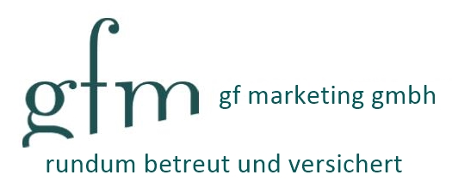
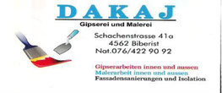
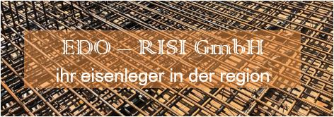
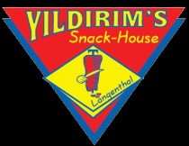

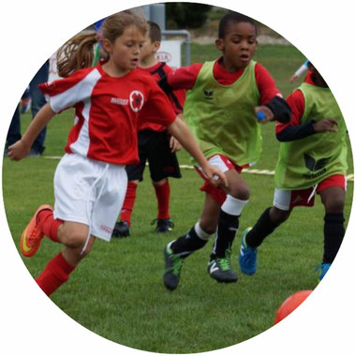
FLB Rental, Oftringen
Fraisa SA, Bellach
Fran Dedaj, Niederbipp
Freestyle Garage, Derendingen
Garage West, Rothrist
Gebrüder Sopi GmbH, Zuchwil
Grob Fitness GmbH, Bellach
Häni + Co. AG, Arch
Helvetia Versicherungen, Solothurn
Honegger AG, Köniz
Itema Switzerland Itd, Zuchwil
Kenni AG, Zug
Köbi Generalagentur GmbH, Bannwil
Kurti Bodendesign GmbH, Wolfwil
Leo-Risi GmbH, Zuchwil
Muttscheller Metallbau GmbH, Biel
Ostfinanz GmbH, St. Gallen
Pasha Food GmbH, Grenchen
Pizza Kebab Haus, Biberist
PrimeLine GmbH, Wiedlisbach
PRODEGA, Bellach
RAMI GmbH, Adlikon Regensdorf
Restaurant Post, Luterbach
Rieder Beratung Sport und Gesundheit, SO
Sabato Microtec, Biel
SAM AG, Roggwil
SANDI Gipsen Malen, Lüterkofen
Sauber Tankrevisionen, Hägendorf

Shisha Nara Lounge, Zuchwil
Siegrist AG, Grenchen
SOCARS AG, Bellach
SQ Architekten GmbH, Zofingen
TK Farbgestaltung GmbH, Uznach SG
U-Boot Stadt Grill, Solothurn
Vivere Emozioni by Daniela, Zuchwil
Yildirim's Snack House, Langenthal
Zberg Motorgeräte AG, Subingen

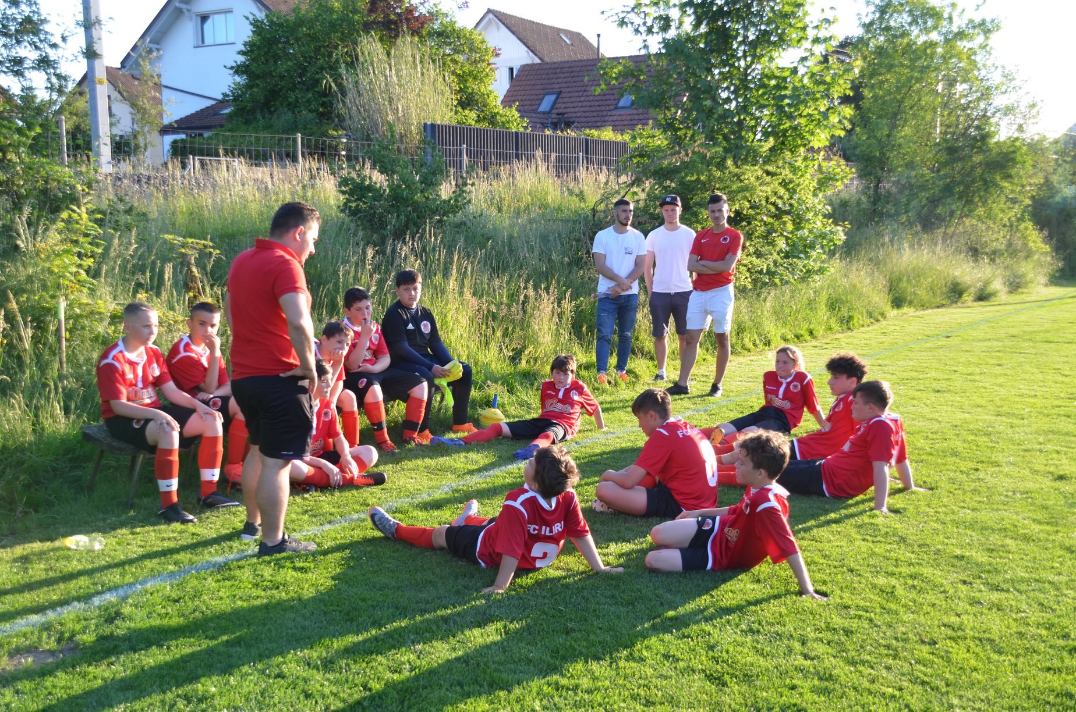
Herzlichen Dank an die Matchballspender!

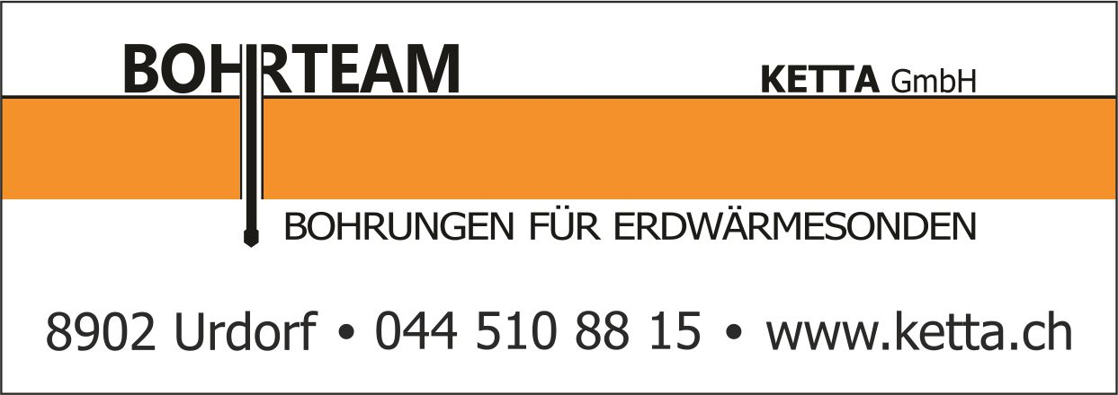
Mannschaftslisten
Die Mannschaftslisten werden präsentiert von: Partner

FC ILIRIA |  |  | FC LAUSANNE-SPORT
1 | Trittibach Nicola |  | 1 | Castella Thomas
21 | Shkoreti Laurent |  | 18 | Dany Da Silva
4 | Spaiu Syart |  | 40 | Mory Diaw
5 | Halimi Avdi |  | 50 | Noah Falk
13 | Latifi Leutrim |  | 6 | Elton Almada Monteiro
16 | Raimi Burim |  | 13 | Per-Egil Flo
18 | Sulejmani Dashnim |  | 23 | Igor Nganga
20 | Zizak Ivo |  | 24 | Noah Loosli
24 | Dedaj Dugagjin |  | 25 | Nikola Baranisajevic
6 | Llugaliu Dardan |  | 30 | Nicolas Gétaz
7 | Jahiu Alban © |  | 37 | Ange Mikaél Nanizayamo
8 | Sadriji Mergim |  | 7 | Stjepan Kukurozovic
10 | Mustafi Egzon |  | 8 | Joél Geissmann
11 | Sasso Mattia |  | 14 | Alexandre Pasche
12 | Mustafi Memnum |  | 17 | Jöao Oliveira
14 | Gedici Hasan |  | 20 | Maxime Dominguez
15 | Dhillon Jasminder |  | 21 | Cameron Puertas
17 | Caroli Riccardo |  | 22 | Sinclair Baddy Dega
22 | Elezi Nazim |  | 42 | Gabriel Bares
23 | Dakaj Bleron |  | 9 | Andi Zeqiri
26 | Perkolaj Denis |  | 10 | Sancidino Silva
9 | Prenaj Samuel |  | 11 | Antony Coura
19 | Aliu Duan |  | 27 | Dan Ndoye
25 | Idrizi Bleon |  | 33 | Isaac Schmidt
27 | Andrijasevic Oliver |  | 39 | Josias Lukembila
 |  |  | 99 | Aldin Turkes
COACH | DEDAJ VILSON |  | COACH | GIORGIO CONTINI
AS/COACH | LEO SASSO |  | AS/COACH | UMBERTO ROMANO

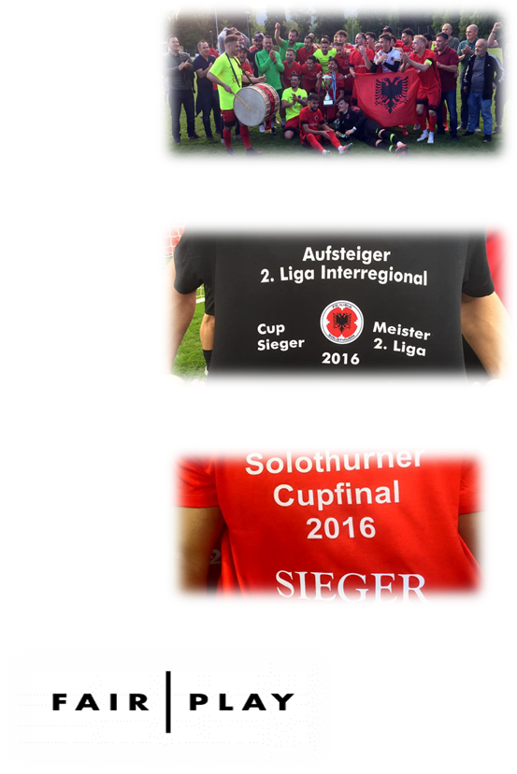
Leo.S Coiffeur, Biel-Bienne
Gjezair Zeka, Oensingen
Beetle Pizza Kebab Haus. Bettlach
CIS Hüttli, Solothurn
Peppone Pizzaservice, Solothurn
Orient Grill Ocakbasi, Zuchwil
Diversa Cosulting, Bern
Generali Agentur, Solothurn
Sphinx Tools AG, Derendingen
Auto Abegglen AG, Worblaufen
Tecton GmbH, Niederbipp
Gostivar Handels GmbH, Rothrist
Palmyra Lounge, Solothurn
Bodymechanic Switzerland, Subingen
Petrol Station Gastro GmbH, Bellach
Rrahmani Zimmerei & Holzbau, Derendingen
SATHI GmbH, Roggwil
Rhino Gym GmbH, Langendorf
Creaplan GmbH, Wynau
Group Fitness GmbH, Bellach
JAJA Immobilien AG, Biberist
Cimi `S Pizza Kebab Asianfood, Biberist
Swiss Well Care GmbH, Burgdorf
LDK – Dega Zvicer

